Here is the design of the interface for customers of our hotel chain.

First of all, when they arrive, if there is a big queue at the reception, it exists the possibility to use the automatic reception to do the check-in or even the booking of a room:

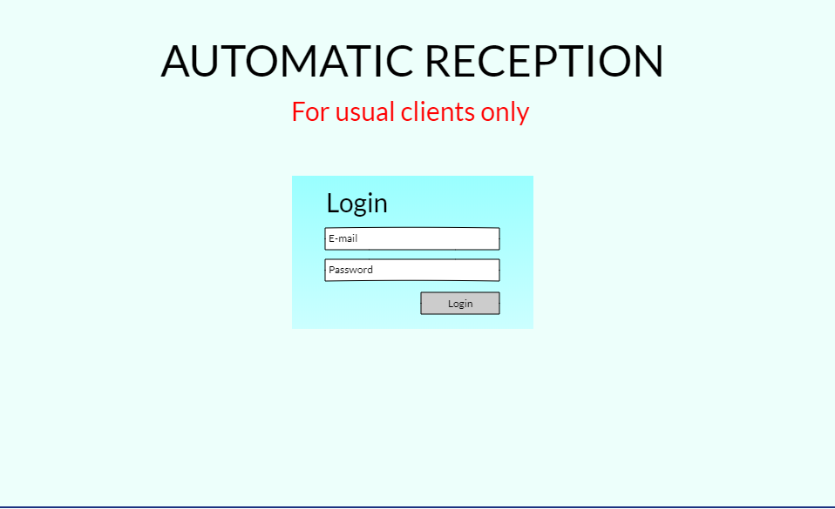

After we login, we find a screen where you can choose whether you want to do a check-in, consume a service in the hotel or do the check-out:

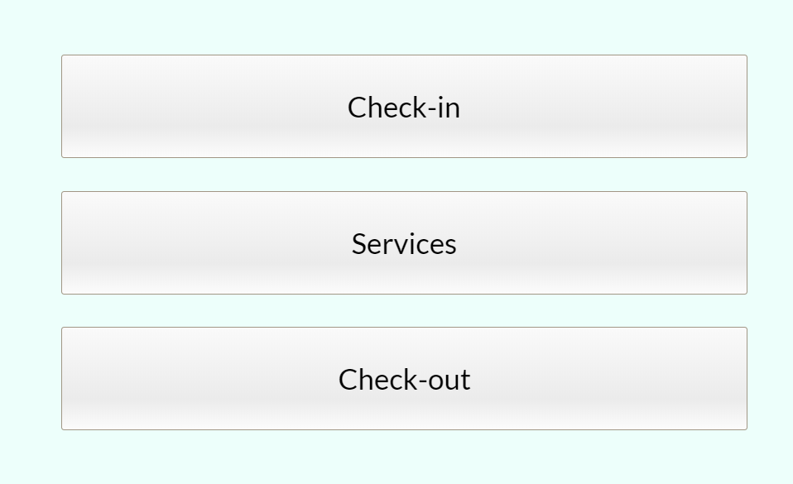

If we touch the check-in option (assuming we are using a tactile screen), we find this two options, where you can select if you want to get the key (of previous online reservations) or book a room in that moment (maybe there is no a free room)

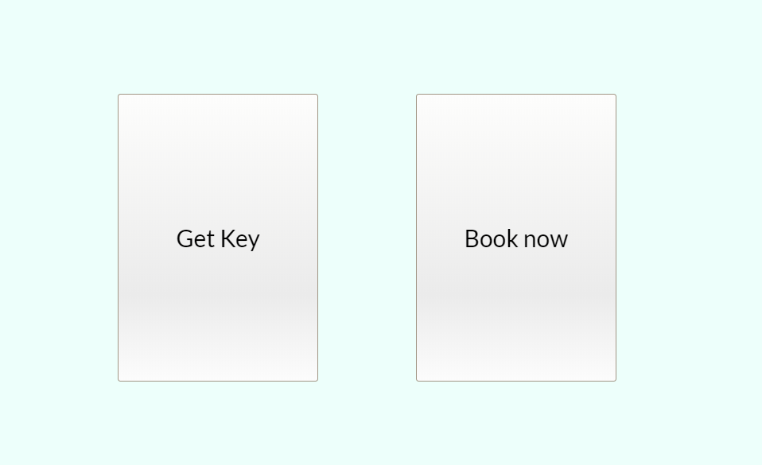

If you touch the “book now” button, you get to the following screen. You can select the time you want to stay in the hotel as well as the number of persons that are going to stay in.

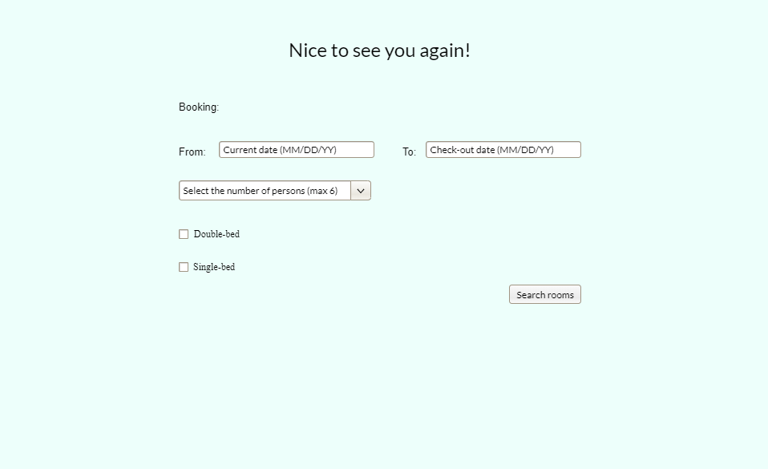

As you are a premium customer, you can select the room where you want to stay at:

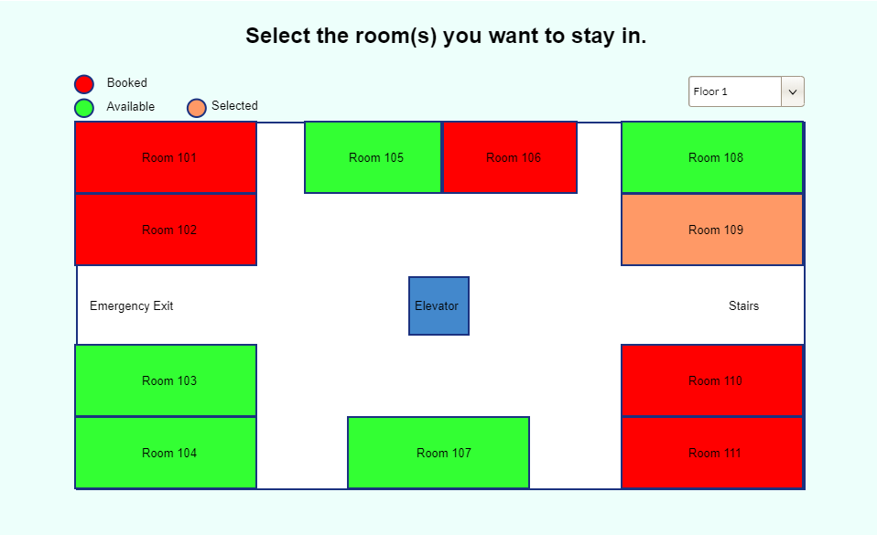

Then, the key is given by the automatic receptionist. This screen is the same if you click in the “Get Key” option of the third screen shown in this pdf.

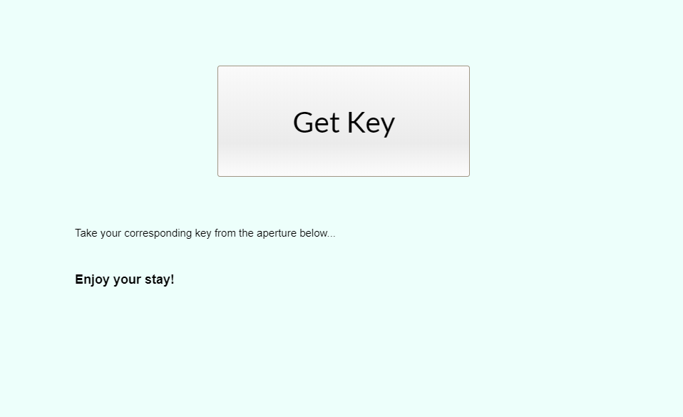

Once you are in your room, you have access to a tv where you can order several services by voice or by touch. Also you have this possibility at the tv of the bar. You can enter in this menu if you touch the “Services” button of the second picture of this pdf.

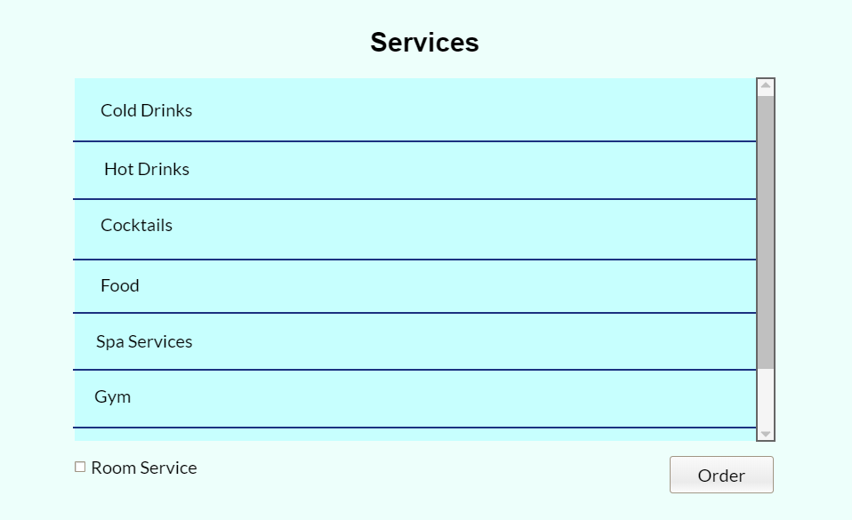

At the end of your stay, you can automatically do the check-out in the screen of your own room touching the “Check-out” option of the second picture of the pdf, where the information of your stay will appear, you can pay for it, and you can choose whether to get a bill or not. 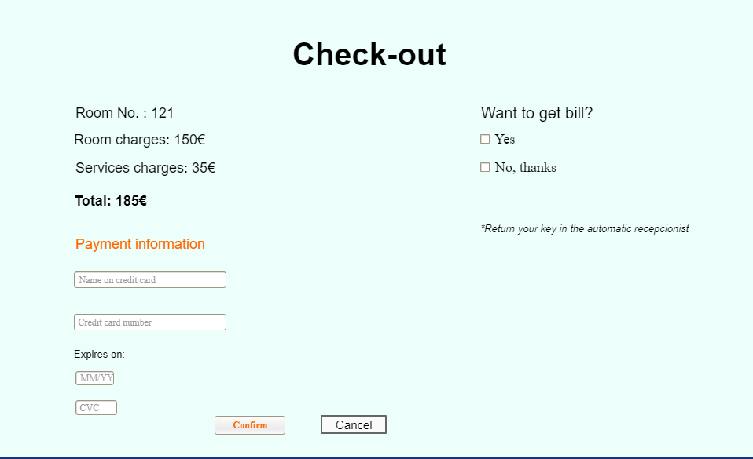.

Finally, you may return your key at the automated receptionist, so you avoid waiting your turn...and continue with your journey!